Solder Reflow Oven

Ahmad Mujtba (2023070), Hamza Saleem Barg (2023224)

*Ghulam Ishaq Khan Institute of Engineering Sciences and Technology*

***Abstract*—This project implements a real-time temperature control system for a solder reflow oven using the PIC18F4550 microcontroller. A MAX6675 thermocouple amplifier with a K-type thermocouple monitors the oven temperature. A PID algorithm adjusts heating and cooling through PWM-driven control of a 12V PTC heater and 12V DC fan using IRF450N MOSFETs. A 16x2 LCD displays the temperatures. The system transmits temperature data to a PC via a USB-to-TTL converter, where a live temperature vs. time curve is plotted. Setpoints change every 5 seconds to simulate a typical reflow temperature profile.**

***Keywords: PID temperature control, MAX6675, PIC18F4550, K-type thermocouple, PWM, MOSFET switching, reflow oven, real-time plotting, embedded system.***

1. **INTRODUCTION**

## Background and Context

Precise temperature control is essential in reflow soldering, where components are bonded to PCBs using heat. Traditional ovens lack feedback and result in poor solder quality. Embedded systems enable the automation of temperature profiles using sensors and controllers. Microcontrollers such as the PIC18F4550 provide the necessary interfaces (ADC, PWM, UART, SPI) for implementing such solutions.

## Problem Statement

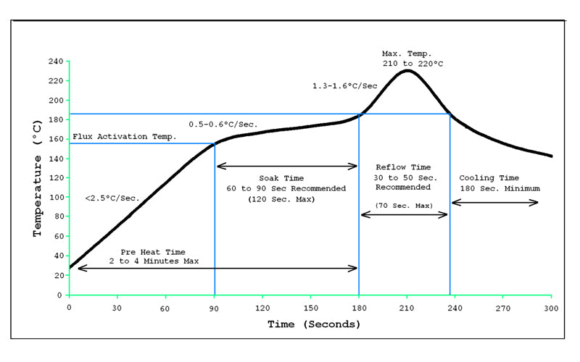Maintaining a dynamic temperature profile suitable for soldering requires accurate sensing and fast control over the heat and cooling mechanisms. Manual control is inadequate due to lag, overshoot, and inconsistency. The challenge is to design a system that can follow the temperature-time curve of a soldering cycle using minimal hardware and embedded C code.

Fig. 1. Temperature Curve to follow

## Objective and Scope

* Use PIC18F4550 to implement a PID-based temperature controller.
* Interface the MAX6675 via SPI to read temperature.
* Display data on a 16x2 LCD and send it to a PC via UART.
* Use PWM to control a 12V PTC heater and fan via IRF450N MOSFETs.
* Implement automated setpoint transitions every 5 seconds.
* Plot real-time data for comparison with standard reflow profile.

## Significance and Relevance

The project provides a foundational example of how embedded systems can be applied in industrial process automation. It integrates sensors, actuators, and controllers into a cohesive system, demonstrating real-time monitoring and control. The design emphasizes modularity, enabling easy customization or expansion for different applications. With its focus on practical implementation, the project offers scalability and portability, making it well-suited for both educational demonstrations and industrial prototyping. Additionally, it highlights the potential of embedded systems to enhance efficiency, precision, and safety in automated processes.

# Literature Review

## Traditional Temperature Control

Conventional systems use thermostats or analog controllers. These are simple, low-cost, and widely used in basic heating applications such as room heaters and water boilers. However, they offer poor performance in dynamic systems like reflow ovens due to the lack of precise feedback and limited response control. Thermostats typically operate in a binary on/off mode, switching the heater fully on or off based on a fixed temperature threshold. This results in significant temperature overshoot and oscillation, especially in systems where temperature needs to change rapidly or follow a defined profile. Moreover, analog controllers, while slightly more responsive, rely heavily on manual calibration and lack the ability to adapt to varying load conditions or external disturbances.

In applications like reflow soldering, where specific temperature-time profiles must be maintained across different zones (preheat, soak, reflow, and cooling), these traditional methods fall short. They cannot handle the fine granularity needed to follow complex, time-varying setpoints, nor can they compensate for thermal inertia or system delays. As a result, components may be under-heated, over-heated, or experience thermal shock, all of which can compromise solder joint quality and reliability. Additionally, these systems provide no mechanism for data logging, fault diagnosis, or user interface, which limits their suitability for controlled manufacturing environments.

To address these limitations, modern digital controllers with closed-loop feedback have become the standard in precision temperature control. These systems continuously monitor actual temperature and adjust the heating or cooling power intelligently, leading to faster response times, reduced overshoot, and improved thermal stability.

## Modern Comparator-Based Protection Circuits

Modern systems employ digital sensors and PID algorithms to overcome the limitations of traditional analog controllers. The MAX6675, for instance, provides precise digital temperature readings directly from a K-type thermocouple, eliminating the need for signal amplification, filtering, or analog-to-digital conversion. This simplifies the hardware design and improves accuracy. PID (Proportional-Integral-Derivative) control algorithms further enhance system performance by continuously calculating the error between the measured temperature and the desired setpoint, and dynamically adjusting the output PWM signals sent to heating and cooling elements. This results in minimized overshoot, reduced steady-state error, and faster settling times. When combined with microcontrollers like the PIC18F4550—which offers built-in SPI, UART, and CCP (PWM) modules—these systems provide a flexible, programmable, and real-time control solution suitable for dynamic applications like reflow ovens, where tight thermal control is essential

# Design and simulation

The **PIC18F4550** is a powerful 8-bit microcontroller from Microchip featuring built-in USB support, multiple I/O ports, timers, PWM, and SPI communication, making it suitable for precise control and data handling in embedded systems. The **MAX6675** is a thermocouple-to-digital converter IC that interfaces with a **K-type thermocouple** to accurately measure high temperatures, which are essential for monitoring and controlling the heating profile in a reflow oven. The **IRF450N** is an N-channel MOSFET capable of handling high current, used here as a switching element to control power delivery to the heater and fan via PWM signals from the microcontroller. The **12V PTC heater** serves as the heat source for the reflow process, providing self-regulating thermal output that enhances safety and stability. The **12V DC fan** ensures air circulation inside the oven chamber, helping maintain uniform temperature and cooling during the final stage of the soldering process. The **16x2 LCD** is used to display real-time temperature readings and status messages, providing user feedback during operation. Finally, the **USB-to-TTL converter** connects the PIC18F4550 to a computer, enabling temperature data logging or graph plotting via serial communication, which is useful for analyzing and fine-tuning the reflow profile.

**TABLE I**

Components used

|  |  |  |
| --- | --- | --- |
| S. No | Name | Type |
| S. No | Component | Description |
| 1 | PIC18F4550 | Main controller |
| 2 | MAX6675 + Thermocouple | Temperature sensing (SPI) |
| 3 | IRF450N | MOSFETs for heater/fan control |
| 4 | 12V PTC Heater | Heating element |
| 5 | 12V DC Fan | Cooling mechanism |
| 6 | 16x2 LCD | Data display |
| 7 | USB-to-TTL Converter | Serial data to PC for plotting |

## Circuit Design

Table I. shows all the components used in the circuit. The core of the temperature control system is the PIC18F4550 microcontroller, which provides the computational capability and peripheral support required for sensor interfacing, PWM signal generation, user display, and serial communication. The MAX6675 thermocouple amplifier is used for precise temperature sensing and communicates with the microcontroller through the SPI protocol. The SCK, SDI, and CS of the microcontroller are used to establish a serial interface with the MAX6675. The thermocouple (K-type) is connected to the MAX6675, allowing accurate digital temperature data to be transmitted directly without the need for external amplification or analog conversion.

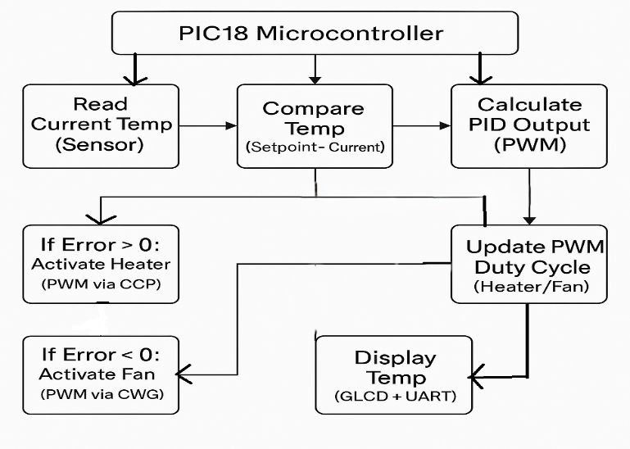

The heater and fan are driven using two IRF450N N-channel power MOSFETs, which act as high-speed electronic switches. These MOSFETs are controlled by PWM signals generated through the CCP modules of the PIC18F4550. The CCP1 module is configured to generate a PWM signal on pin RC2, which is connected to the gate of the MOSFET controlling the heater. Similarly, the CCP2 module generates PWM on pin RC1 for the fan control MOSFET. Each MOSFET is connected in a low-side switching configuration, with its drain tied to the negative terminal of either the PTC heater or the 12V DC fan, and its source connected to ground.

To monitor and display the system status, a 16x2 character LCD is interfaced with the PIC18F4550 in 8-bit mode. The data lines of the LCD are connected to PORTD pins, while the RS and E control lines are connected to RE2 and RE0 respectively. This configuration ensures efficient use of I/O pins while maintaining proper functionality. The LCD displays real-time temperature readings from the MAX6675 and the current setpoint, which changes dynamically during the operation. The system updates the display periodically in the main control loop.

To enable real-time plotting and monitoring, temperature data is transmitted to a computer via a USB-to-TTL converter module. The UART transmit line (TX) of the PIC18F4550 is connected to the RX input of the converter. The UART is configured in asynchronous mode with a standard baud rate (e.g., 9600 bps), allowing temperature data to be streamed in CSV or raw format to a serial plotter or terminal on the host PC. This setup facilitates graphical overlay comparisons with a standard reflow temperature curve in Arduino IDE serial plotter.

The power section of the circuit includes a regulated 12V DC input, which supplies both the heating element and the cooling fan. The microcontroller and other logic-level components are powered through a 5V supply. Bypass capacitors are placed near the microcontroller’s VDD and VSS pins to suppress power supply noise.

Internally, the firmware uses a PID control algorithm that calculates an error term between the current temperature and the desired setpoint, and adjusts the PWM duty cycles accordingly. The setpoint itself is updated every 5 seconds to mimic the heating profile of a standard solder reflow oven. The PWM signals modulate the average voltage applied to the heater and fan, effectively controlling their power and thus influencing the temperature trajectory inside the oven.

In summary, the circuit integrates precise digital temperature sensing, efficient power switching, real-time display and communication, and closed-loop PID control into a compact embedded system. The integration of all components in Proteus simulation confirms the operational logic and facilitates testing before hardware implementation

Fig. 2. Circuit’s Design in Proteus

## Simulation Analysis

The circuit was simulated in Proteus to verify the basic functionality of each module before hardware testing. The PIC18F4550 successfully communicated with the MAX6675 via SPI, and the temperature readings were displayed on the 16x2 LCD alongside the current setpoint. The setpoint changed automatically every 5 seconds, and the system responded accordingly.

PWM signals controlling the heater and fan were observed using virtual probes. As the setpoint increased, the heater’s PWM duty cycle rose, while during the cooling phase, the fan PWM activated. The UART module transmitted temperature data to a virtual terminal, confirming correct serial communication.

The overall system behavior in simulation aligned with expectations: temperature tracking followed the setpoints closely, and transitions between heating and cooling were handled smoothly by the PID controller. The simulation validated the logic and interfacing of all core components.

1. **RESULTS**

The system performed as expected in both simulation and initial hardware tests. The PIC18F4550 correctly read temperature values from the MAX6675 thermocouple module and displayed them in real time on the 16x2 LCD along with the corresponding setpoint. The setpoints changed every 5 seconds, simulating a typical reflow profile.

During operation, the PID controller smoothly adjusted the PWM output to the IRF450N MOSFETs, which controlled the 12V PTC heater and DC fan. When the actual temperature was below the setpoint, the heater was activated with an increasing PWM duty cycle. As the temperature approached the setpoint, the duty cycle reduced to stabilize the temperature. If the actual temperature exceeded the setpoint, the fan PWM began to increase, helping the system cool down.

The system also successfully transmitted temperature data to a PC via the USB-to-TTL converter. The plotted curves for actual temperature and changing setpoints showed close tracking, with minimal overshoot or delay. This confirmed the effectiveness of the PID algorithm in managing thermal response and stability.

Overall, the results verified the system’s ability to automatically track a dynamic temperature profile and maintain control with accuracy and responsiveness. The simulation and measured performance aligned with the design goals of the project.

1. **REFERENCES**
2. ITechSMT, *Each Temperature Zone of SMT Reflow Oven*. ITechSMT, 2021. [online]. Available: <https://www.itechsmt.com/blogs/news/each-temperature-zone-of-smt-reflow-oven>
3. Microchip Technology Inc., *PIC18F4550 8-Bit Microcontroller Datasheet*, [online]. Available: https://www.microchip.com/en-us/product/PIC18F4550
4. Maxim Integrated, *MAX6675 Cold-Junction-Compensated K Thermocouple-to-Digital Converter*, [online]. Available: https://datasheets.maximintegrated.com/en/ds/MAX6675.pdf
5. Vishay, *IRF450N N-Channel Power MOSFET Datasheet*, [online]. Available: https://www.vishay.com/docs/91063/91063.pdf
6. National Instruments, “PID Theory Explained,” *ni.com*, [Online].

Available: https://www.ni.com/en-us/innovations/pid-control.html